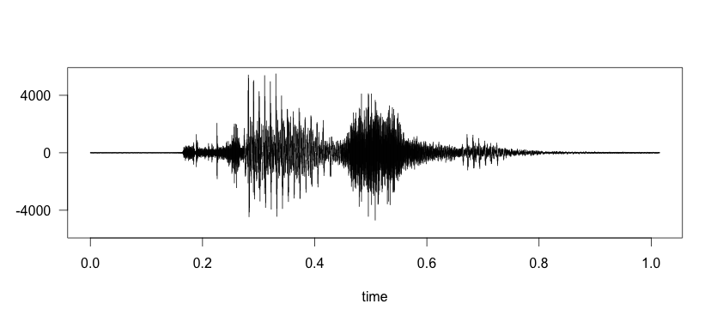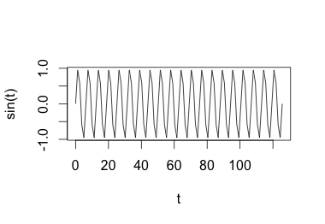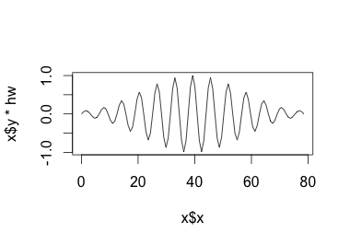

**Pre-emphasize:** Boost the energy of higher

frequency components



**Framing:** assume that a small sample (16 ms) is stationary.



**Windowing:** Smoother transition between frames.

Time Domain



**Mel Frequency Cepstral Coefficients:** based on human perception of frequencies. Only keep the most relevant frequencies.